Batch: C1 Roll No.:16010122221

Experiment / assignment / tutorial No.___9____

Grade: AA / AB / BB / BC / CC / CD /DD

**Signature of the Staff In-charge with date**

**Experiment No.:9**

|  |
| --- |
| **TITLE: Study and configure DHCP & DNS protocol using Cisco Packet tracer** |

**AIM:** To study and configure **DHCP/DNS** protocol using Cisco Packet tracer

**_____________________________________________________________________________**

**Books/ Journals/ Websites referred:**

1. A. S. Tanenbaum, “Computer Networks”, Pearson Education, Fourth Edition
2. B. A. Forouzan, “Data Communications and Networking”, TMH, Fourth Edition

_____________________________________________________________________________

**Pre Lab/ Prior Concepts:**

IPv4 Addressing, Subnetting, Link State Protocol, Router configuration Commands

**_____________________________________________________________________________**

**New Concepts to be learned: DHCP/DNS** Protocol and its configuration.

**_____________________________________________________________________________**

**THEORY:**

Dynamic Host Configuration Protocol (DHCP) is a client/server protocol that automatically provides an Internet Protocol (IP) host with its IP address and other related configuration information such as the subnet mask and default gateway. All computers on the Internet, from your smart phone or laptop to the servers that serve content for massive retail websites, find and communicate with one another by using numbers. These numbers are known as IP addresses. When you open a web browser and go to a website, you don't have to remember and enter a long number. Instead, you can enter a domain name like example.com and still end up in the right place. A DNS service such as Amazon Route 53 is a globally distributed service that translates human readable names like www.example.com into the numeric IP addresses like 192.0.2.1 that computers use to connect to each other. The Internet’s DNS system works much like a phone book by managing the mapping between names and numbers. DNS servers translate requests for names into IP addresses, controlling which server an end user will reach when they type a domain name into their web browser. These requests are called queries.

**IMPLEMENTATION:**

The cli for router 1 assigning the ip range for each fast Ethernet

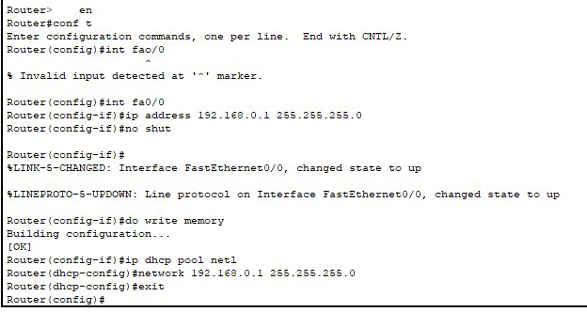

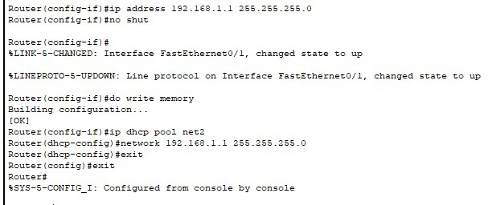

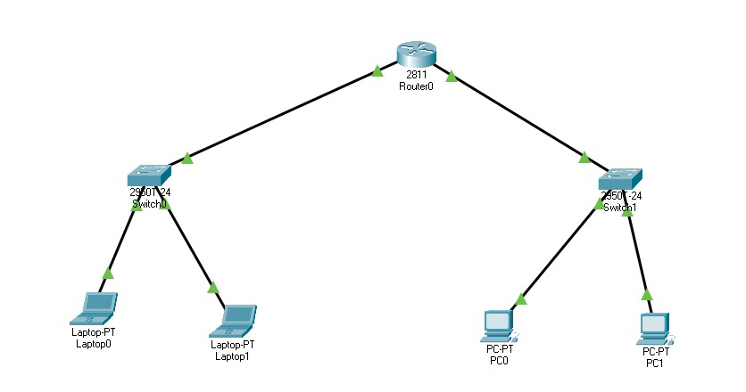

Requesting the IP from DHCP

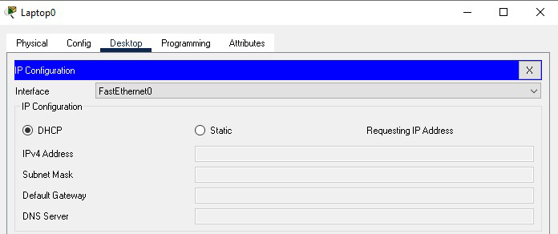

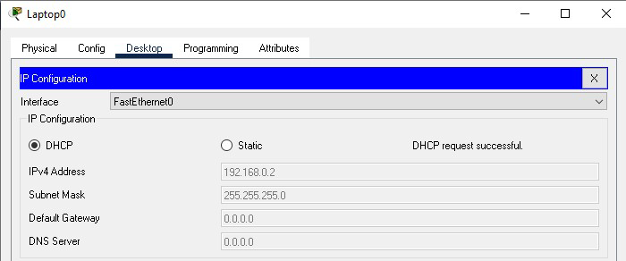

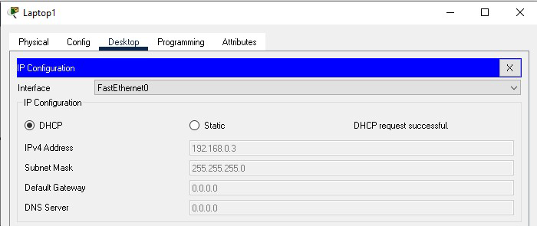

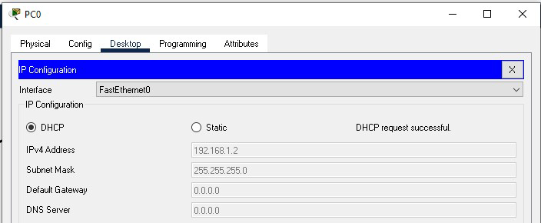

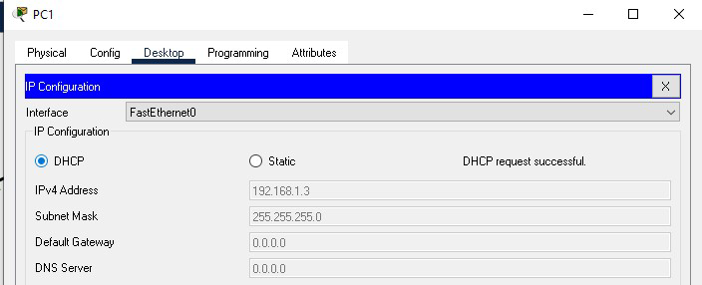

CONCLUSION:

**We successfully studied and configured DHCP/DNS protocol using Cisco Packet tracer**

**Post Lab Questions:**

* 1. **Describe DHCP and DNS with example**

### 1. ****DHCP (Dynamic Host Configuration Protocol)****

**DHCP** is a protocol used to automatically assign IP addresses and other network configuration parameters to devices on a network, so they can communicate with each other. When a device, like a laptop, connects to a network, it needs an IP address to communicate with other devices. Instead of setting this manually, DHCP does it dynamically.

**Example**: Imagine you walk into a café with your laptop, and you want to connect to the Wi-Fi. When your laptop connects to the café's Wi-Fi network, the DHCP server in the café’s router assigns your laptop an IP address automatically. Without DHCP, you would have to manually configure an IP address each time, which would be inconvenient, especially on public networks.

1. **DHCP Discover**: Your laptop sends a broadcast request for an IP address when it connects to the network.
2. **DHCP Offer**: The DHCP server receives the request and "offers" an available IP address.
3. **DHCP Request**: Your laptop sends a request to accept that IP.
4. **DHCP Acknowledgment**: The server confirms the IP address assignment, and your laptop can now use that IP on the network.

### 2. ****DNS (Domain Name System)****

**DNS** is a protocol that translates domain names (like example.com) into IP addresses (like 192.0.2.1). Since humans find domain names easier to remember than IP addresses, DNS is essential for helping us connect to websites and services by name rather than by numerical IP addresses.

**Example**: When you type www.google.com into your browser, your computer doesn’t initially know the IP address of Google’s server. So, it sends a DNS query to a DNS server to find out. The DNS server responds with the IP address, allowing your computer to connect to Google’s server.

1. **DNS Query**: Your computer queries the DNS server for the IP of www.google.com.
2. **DNS Response**: The DNS server replies with Google’s IP address.
3. **Connection**: With the IP address, your browser can connect to Google’s server and load the webpage.

In summary:

* **DHCP**: Assigns IP addresses to devices automatically.
* **DNS**: Translates domain names to IP addresses for easier access to resources online.

4o

**Date: ___________ Signature of faculty in-charge**